Cairo University  
Faculty of Computers and Artificial Intelligent

**CS251**

**Software Engineering I**

Project Name

Software Design

Team Names

Jun-2022

Contents

Team 3

Document Purpose and Audience 3

System Models 4

I. Class diagrams 4

II. Sequence diagrams 6

Class - Sequence Usage Table 8

Ownership Report 9

# Team

|  |  |  |  |
| --- | --- | --- | --- |
| **ID** | **Name** | **Email** | **Mobile** |
| 20200501 | Mahmoud Abdelrady Gadelrab | Mahmoudten55@gmail.com | 01117332086 |
| 20201082 | Zahraa Ahmed Abd elkafy fahmy | Zahraa2002ahmed@gmail.com | 01146594380 |
| 20190775 | Hayat Nasser Saeed | hayat8naser@gmail.com | 01015981662 |
| 20200165 | Hanen Mohamed Ewiss | hanenmohamed473@gmail.com | 01110629701 |

# Document Purpose and Audience

* **Document purpose: This document is a clarification about everything about the application and provide every step in building the application.**
* **Document audience: Subject’s professor and TA.**

# 

# System Models

## I. Class diagrams

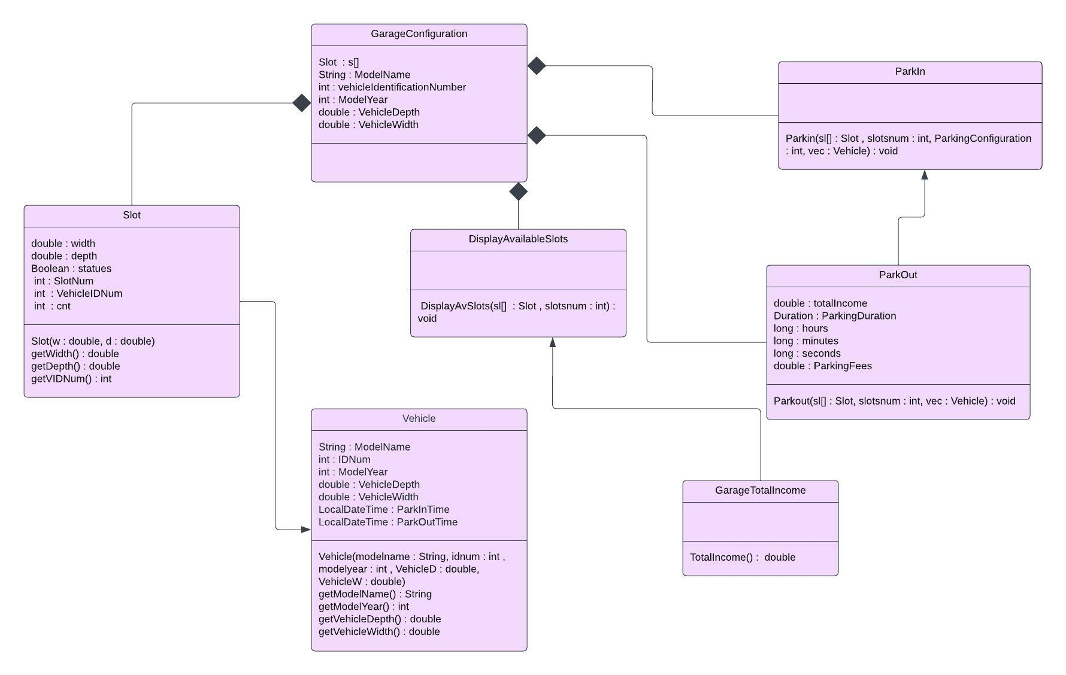

|  |  |  |
| --- | --- | --- |
| Class ID | Class Name | Description & Responsibility |
| 1 | Garage Configuration | This main part of the application which is designed, it contains all the information related to the garage . |
| 2 | Vehicle | Contains all vehicle specifications (model, identification, Model Year, dimensions, color). Vehicles will be parked in the parking spaces. |
| 3 | Slot | Each parking lot will have a parking space. |
| 4 | Park In | that marks the arrival time of a vehicle if there is an available slot . |
| 5 | Park Out | Calculate the total income and the time of exit of the vehicle. |
| 6 | Display Available Slots | Display the available parking slots. |
| 7 | Garage TotalIncome | Calculate the total income |

## II. Sequence diagrams

SequenceID:1

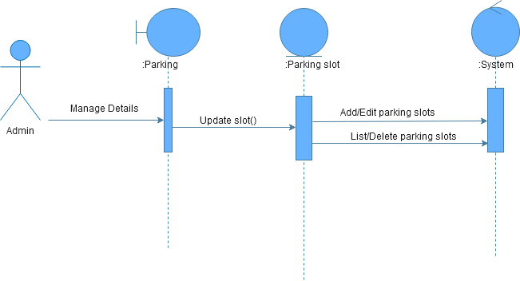

SequenceID:2

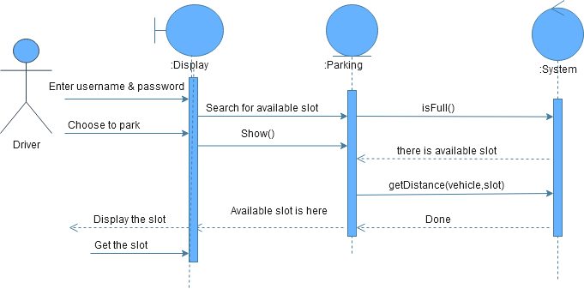

SequenceID:3

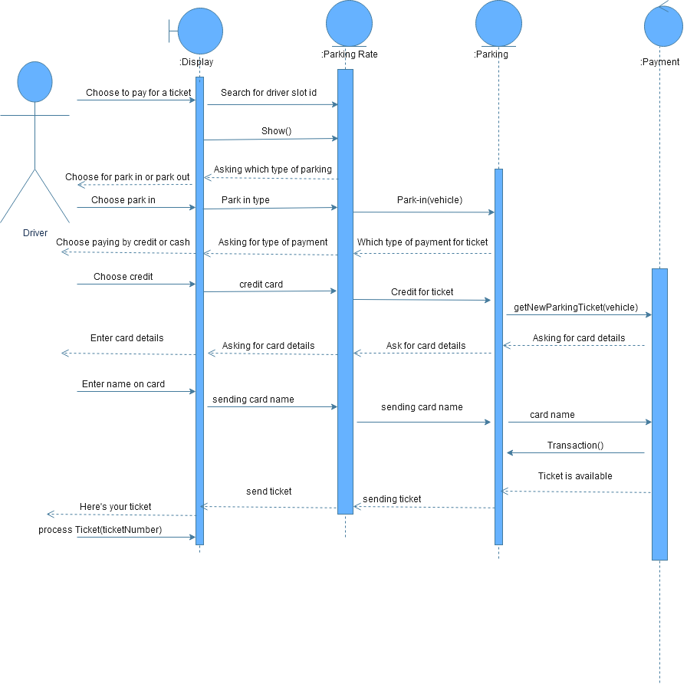

### 

| **Class Name** | **Sequence Diagrams** | **Overall used methods** |
| --- | --- | --- |
| Parking | 1, 2 ,3 | isFull, getDistance,updateSlot,getNewParkingTicket |
| Parking slot | 1 | None |
| Display | 2,3 | Show |
| Parking Rate | 3 | Park-in |
| Payment | 3 | Transaction |

### Class - Sequence Usage Table

# 

# Ownership Report

|  |  |
| --- | --- |
| **Item** | **Owners** |
| Document Purpose and Audience | *Mahmoud Abdelrady Gadelrab* |
| Class diagrams - List classes | *Hayat Nasser Saeed* |
| Sequence diagrams - Sequence Usage Table | *Hanen Mohamed Ewiss* |